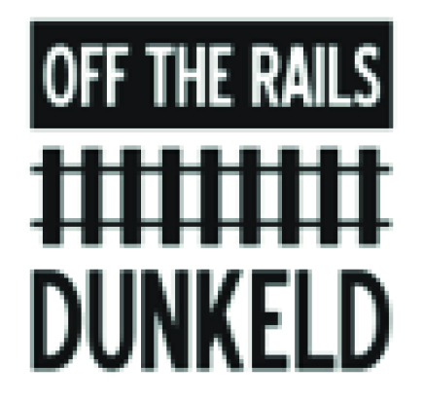
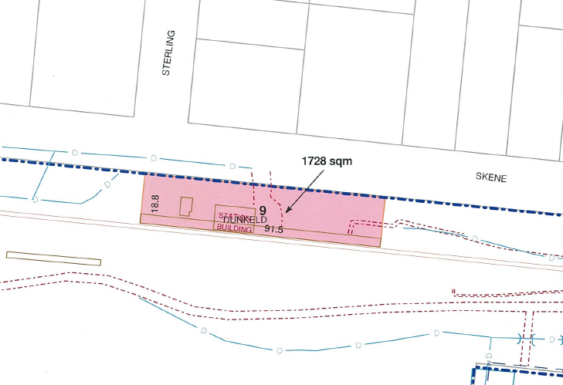
Dunkeld train station has been turned into a community space called Off the Rails Dunkeld. Two buildings are shown on the above map, one comprises of toilet, storage and a small kitchenette containing a microwave, cupboards and sink. The main building is approximately 13m x 6m. There are two large sinks, bench space and tea and coffee making facilities.

Equipment: Artists have use of trestle tables, chairs and easels. The floor is polished concrete and caters for messy work, provided the artist cleans up after themselves. There is hanging equipment on walls.
There is seating for approximately 50 people; this changes due to the COVID restrictions at the time of booking.
There is also platform space and a large concrete area between the buildings which can be used for outside making, including a long sink and tap.

